7KE1 -

Functionality
You can plan profit centers directly in order to modify your planned profits or balance sheet items for the individual profit centers. Planner profiles SAP 800 and SAP810 can be used and are not excel integrated. This example shows usage of an excel integrated layout.

Scenario
Plan PC 1100 for account number 420010 with the value of 15000 and account number 420011 with the value 12000 to be distributed equally for all months in the year 2002 using planner profile and layout 8A-111 for Cost/Revenue. Plan is entered in local currency.

Requirements

Use existing planner profile and layout 8A-111 for Cost/Revenue.

Menu Path | Accounting → Controlling → Profit Center Accounting → Planning → Costs/Revenues → 7KE1 - Change
Transaction Code | 7KE1

1. Double Click on 7KE1 – Change.

Change Plan Costs/Revenues: Characteristics

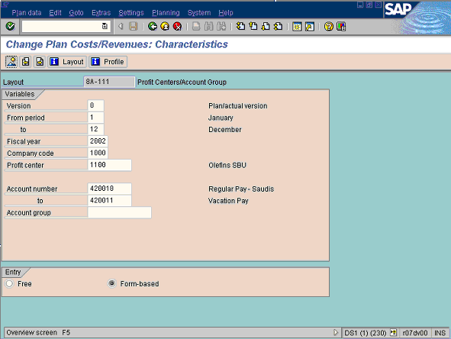
 Existing (integrated with Excel) and layout 8A-111 should be used for this function. This can be set using the following menu path: Planning → Set planner profile.

2. Update the following fields:

Field Name | Field Description | Values
From period | Description of the From period. | Example: 1
To Period | Description of the to period. | Example: 12
Fiscal year | Period, 12 months as a rule, for which the company is to create its inventory and balance sheet. | Example: 2002
Company code | Code identifying the company | Example: 1000
Profit center | Code identifying an organizational object for which an independent operating profit is calculated | Example: 1100
Account number | Code identifying the account to be processed | Example: 420010
To account number | Code of the to account number. | Example: 420011
3. Click Overview Button .
Microsoft Excel
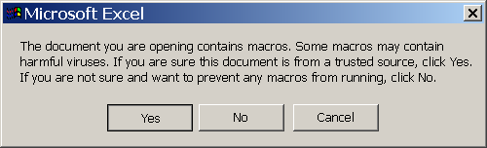
4. Click Yes Button .
 This message is displayed according to the setup of individual PC's.

Change Plan Costs/Revenues: Cumulative values

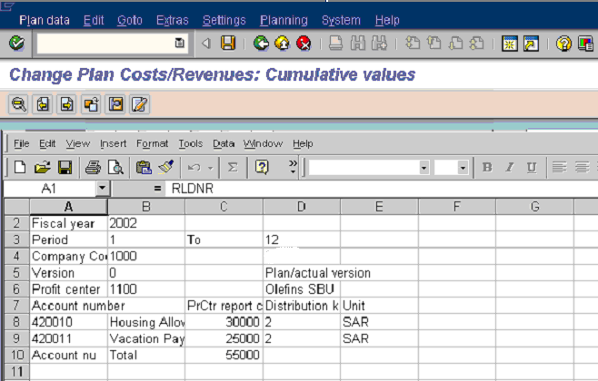

5. Update the following fields:

Field Name | Description | Values
C8 | Amount of Cost Element 420010 | Example: 30000
C9 | Amount of Cost Element 420011 | Example: 24000

6. Click Back .
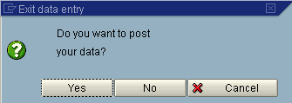
7. Click Yes Button .
8. Click Save .

9. The message bar displays “Data records were posted in document XXXXX”

